Correct Output 1
Send Feedback

What will be the output of the below given code?
<!DOCTYPE html>
<html>
<head>
<style>
.flex-container {
display: flex;
flex-wrap: nowrap;
background-color: #8ffcc9;
width: 400px;
}
.flex-container>div {
background-color: white;
width: 40px;
margin: 5px;
text-align: center;
line-height: 50px;
font-size: 30px;
}
</style>
</head>
<body>
<div class="flex-container">
<div>1</div>
<div>2</div>
<div style="flex-grow: 3">3</div>
<div>4</div>
<div>5</div>
<div style="flex-shrink: 2">6</div>
<div>7</div>
</div>
</body>
</html>

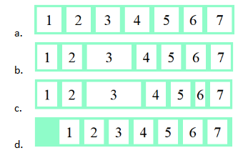

Ans: b

